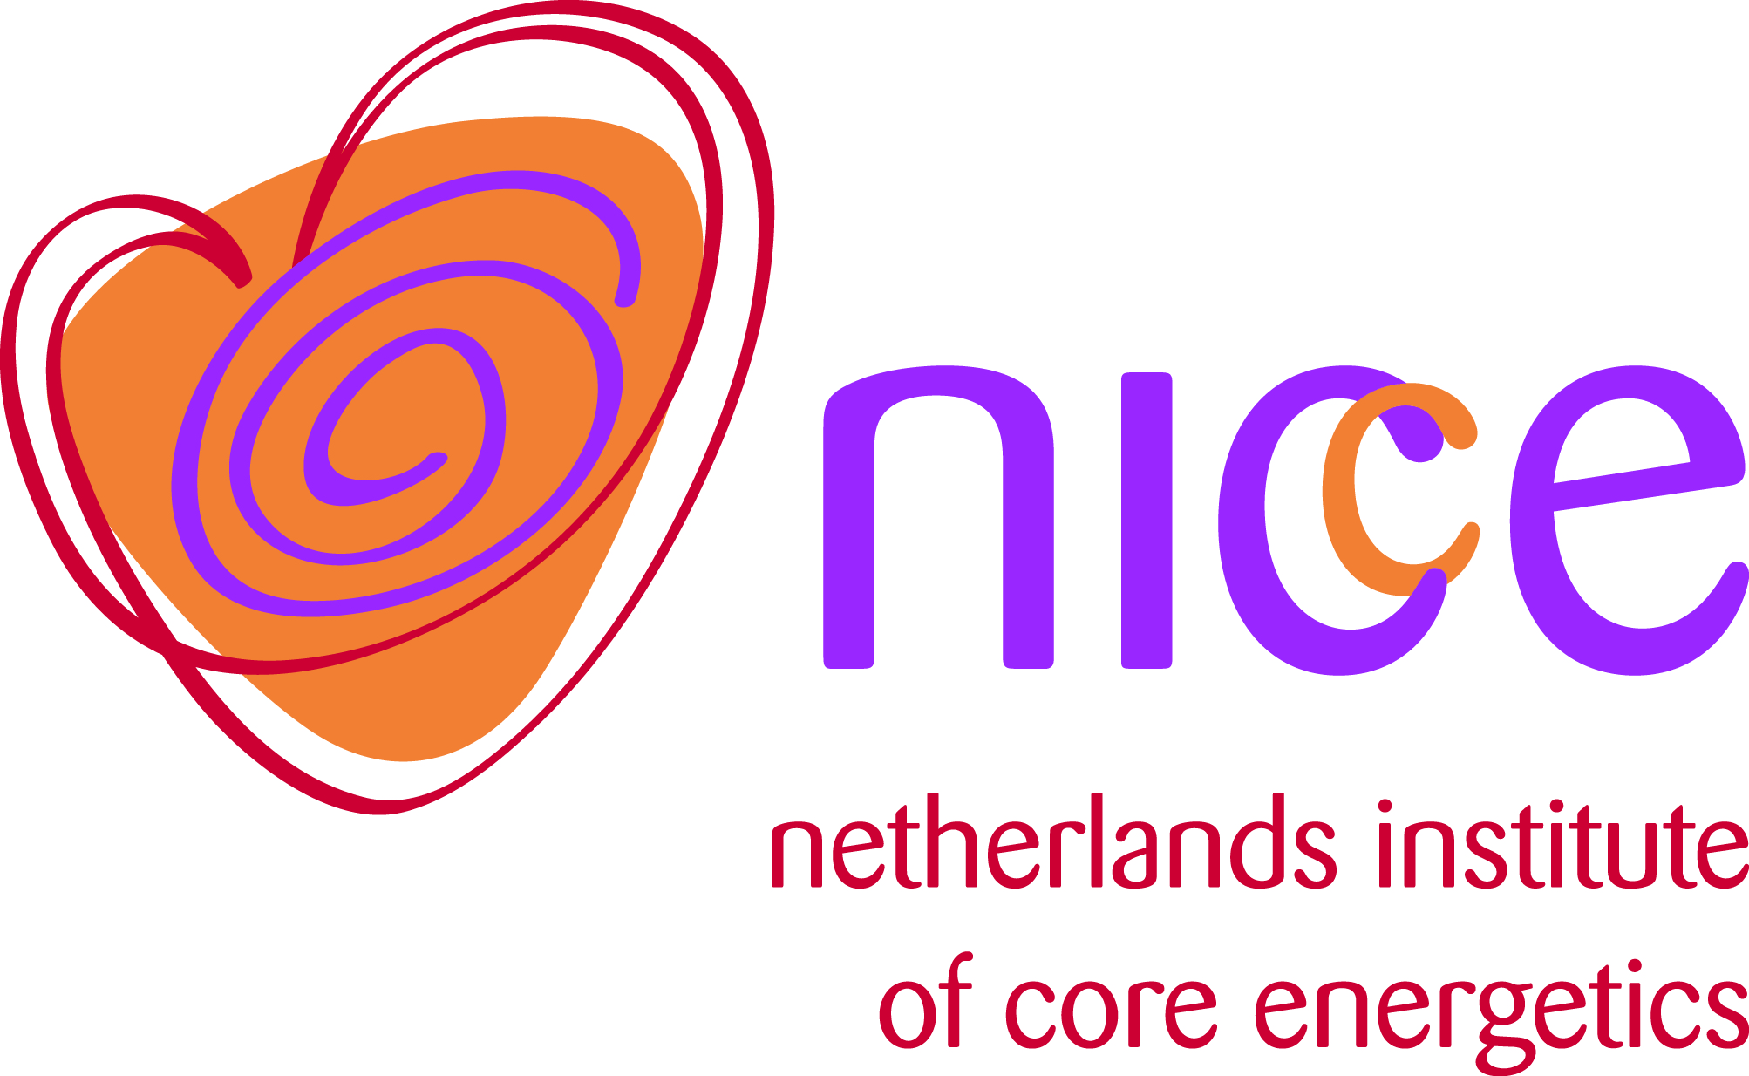

Enrolment form Core Energetics Evolutional Program

We ask you to fill out this form in preparation for an intake interview. Only after the interview and when the enrolment committee approved your enrolment, you decide whether or not to enter the program. Your enrolment will be final upon signing the Program Agreement.

Name:

Address:

Town / city + postal code:

Country:

E-mail address:

Telephone:

Date of Birth:

Gender:

Work:
Function (current situation):
Number of hours per week:
Since when:
Other work experience:

Education / training

1. Which education and training / courses / workshops have you done and in which year did you complete them?

Therapy

1. What experience do you have with (body) psychotherapy?

2. Are you having therapy at the moment? If so, in which form?

3. Are you willing to work on yourself?

Core Energetics Program

1. What is your motivation to follow the Core Energetics Evolutional Program?

2. What appeals to you in this method of working?

3. What are your personal learning goals and what do you expect from this program?

General conditions

I confirm to have taken notice of the general terms and conditions and the
privacy regulations (in Dutch: algemene voorwaarden and privacyreglement) click this link to find these documents

Date:

Signature:

Send this form to: info@coreenergetica.nl

